A000-Afr- Yoruba-Nigeria-Eshu-Divination Tray-mid 20th c

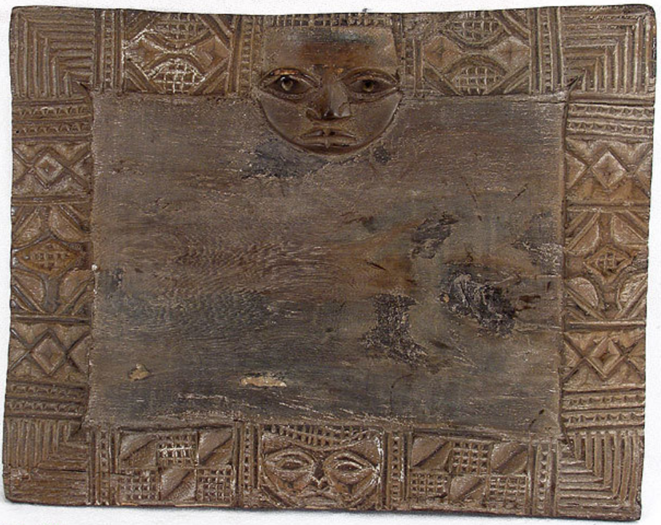

Fig. 1. Afr-Yoruba-Nigeria-Eshu-Divination Tray-mid 20th c

**Case No.: 6**

**Accession No.**

**Formal Label:**

**Display Description:**

This is a divination tray in rectangular shape. The edges on this tray are decorated with finial and complex geometric patterns including face, cowrie shells like motifs and adz.  Traces of ritual white pigment can still be seen on the surface. These trays are used by a priest-diviner (known among the Yoruba as a Babalawo) during divination directed to prevent illness or forestall bad luck. Yoruba Ifa oracle trays are marked by the head of Eshu, which is positioned opposite the diviner.

At the core of Yoruba traditional religion in Nigeria is the ritual of divination, "Ifa," which is performed by the priest-diviner or " Babalawo" who, in the performance of divination, chants from a vast body of oral literature or "Odu", much of which has been preserved by William Bascomb ([1969] 1991). The divination board or platform depicted here has a border decorated with complex motifs including two faces, cowrie shells and adzes and geometric patterns of grids, chevrons, crosses and parallel lines,.  Traces of ritual white pigment can still be seen on the surface. The board acts as a connection between the spiritual universe and that of mortals through a series of complicatedmanipulations of sixteen palm nuts or "ikin" or by the toss of a chain or "opele" of eight half seed shells. Eshu who is depicted as the face on the top of this divination board is the trickster god who is the intermediary between the dead and the living. The figure below represents. diviner. These trays function as an aid to preventing illness or forestalling bad luck. Some erosion and discoloration exists on this divination board due to age and use, aged patina.

**LC Classification:**

**Date or Time Horizon:**

**Geographical Area:**

**Map:**

**GPS coordinates:**

**Cultural Affiliation:**

**Media: wood, kaolin**

**Dimensions:** 11.75 inches W. x 9.25 in

**Weight:**

**Condition:**

**Provenance:**

**Discussion:**

**References:**

Bascomb, William. [1969] 1991. *Ifa divination: communication between gods and men in west Africa* Bloomington and Indianapolis: Indiana University Press.

Thompson, R. F. [1971] 1976. *Black Gods and Kings: Yoruba Art at UCLA*. [Originally published as: Occasional Paper, No. II, Museum and Laboratories of Ethnic Arts and Technology, University of California, Los Angeles] (Bloomington, London: Indiana University Press, 1976)

Hans Witte, The Yoruba Artist, in Abiodun Rowland, John Pemberton, III, Henry J. Drewal, eds. 1994. *The Yoruba Artist: New Theoretical Perspectives on African Arts*. Washington, D.C.: Smithsonian Books.